

department of Computer Engineering & Applications
INSTITUTE OF ENGINEERING & TECHNOLOGY

B.Tech. IV Year CSE/CCV/DA

Project Report

On

“AIR DRAWING USING PYTHON”

Under the supervision of Submitted by
1. Pushkar Krishna Ojha (Sec-C/37/171500246)
Mr. Pawan Kumar Verma

Group No: G-42

Odd Semester, 2020-21



Department of computer Engineering and Applications

GLA University, Mathura

17
km. Stone NH
#2, Mathura
-
Delhi Road, P.O.
–

Chaumuha,

Mathura
–

281406

Declaration

We hereby declare that the work which is being presented in the Major Project “AIR DRAWING USING PYTHON”, in partial fulfilment of the requirements for Major Project viva voce, is an authentic record of our own work carried under the supervision of “MR. PAWAN KUMAR VERMA” .

Signature of Candidate:

Name of Candidate: Pushkar Krishna Ojha

Roll. No.: 171500246

Course: B. TECH CSE

Year: 4rd Year Semester: VIIIth Semester

ACKNOWLEDGEMENT
att

On successful completion of my project thus I would take a privilege to thank thesupporting man power of our faculty members, industrial guide and all my friends & colleagues with gratitude. However, we wish to make special mention of the following.

First of all, I’m are thankful of my internal guide MR. PAWAN KUMAR VERMA and all the friends and mentor of CEA department under whose guideline I was able to complete my project up to valuable mark. I’m wholeheartedly thankful to them for giving me their value able time and attention, and for providing me a systematic way for completing my project in time.

PUSHKAR KRISHNA OJHA

ABSTRACT

- AIR DRAWING USING PYTHON this is a simple computer vision based project which tracks a target and uses the said target to draw on air. The motion of the target is captured by a webcam. The video from the webcam is processed by the computer to get an AR like image overlay on top of the live footage. This project make use of a web cam to track the motion of the target.
- Each frame in the video is blurred using Gaussian blur to get a smooth image. The blurred image is then analysed to get the location of the pointing target. The image is then masked and centroid of target is found. Then a line is drawn from current frame to the previous frame. We will be using the computer vision techniques of OpenCV to build this project. The preferred language is Python due to its exhaustive libraries and easy to use syntax but understanding the basics it can be implemented in any OpenCV supported language
- Color Detection and tracking are used in order to achieve the objective. The color marker is detected and a mask is produced. It includes the further steps of morphological operations on the mask produced which are Erosion and Dilation. Erosion reduces the impurities present in the mask and dilation further restores the eroded main mask.
.

TABLE OF CONTENT
- CHAPTER 1 - Introduction
1.1 Motivation and Overview...........................................................................7
1.2 Aim and Objective .....................................................................................8
1.3 Features and Functions................................................................................8
1.4 Requirement Analysis.................................................................................9
- CHAPTER 2 - Software Requirement Analysis

2.1 Feasibility Study.........................................................................................12
2.2 System Analysis.........................................................................................14

- CHAPTER 3 – System Design
3.1 Hardware Requirements.............................................................................16
3.2 Software Requirements...............................................................................16
3.3 Technical Requirements.............................................................................16
  - Technology To Be Used.............................................................................18
3.5 Use Case Diagram for system.....................................................................21

- CHAPTER 4 – Design
4.1 Software Model Followed..........................................................................23
4.2 Colour Tracking Of Object........................................................................25

4.3 Contour Detection of the mask of colour object ……................................27

4.4 Drawing Line using Position of Contour ……………................................27

4.5 Drawing the points ……………………………..……................................29

4.6 Data Flow Diagram…………………………………..................................30

- CHAPTER 5 – Coding…………………………………………………..31
- CHAPTER 6 – Implementation And Screenshots
6.1 Implementation…………............................................................................35
6.2 Screenshots...................................................................................................36
- CHAPTER 7 – Advantages And Maintanence
7.1 Advantages....................................................................................................38
7.2 Maintanence...................................................................................................40
- CHAPTER 8 – Reference…………………………………………………………41

Chapter 1
Introduction
1.1 Motivation and Overview
To do so, we first set out to create an image mask that would separate the hand from the background. This is a method obtained from Izane’s Finger Detection tutorial1, chosen because of its use of convexity detection; in other words, determining the valleys between the fingers. In doing so, our project’s design changed as we discovered different image processing algorithms. The histogram is then used in a built-in OpenCV function, cv2.calcBackProject , to separate the features in an image. Using a grid of 9 small rectangles, pixel data from each rectangular region is used to create a color histogram. In this case, the program is separating all pixels containing the appropriate colors from the rest of the frame. This proved to be very handy because with some abstraction, we could extract the farthest point coordinate to map to our drawing functions. However, we discovered that the camera’s sensitivity to the lab room’s lighting made this a difficult endeavor, and we often encountered extraneous silhouettes in our processed image.
We then discovered a suitable finger detection algorithm, which first takes a color histogram of the palm to adapt to changing light conditions. From the contour, algorithm detects convexity defects, which indicate where the fingers might be. According to the OpenCV website, contours are curves which join continuous points of the same color or intensity, and are used for shape analysis and detection3. The current image is captured and processed when the user presses Z on the keyboard. We began our project by searching for open source hand gesture recognition software that utilized OpenCV in combination with Python. Our primitive implementation sought to use hand gestures to control our color and size variables. With some trial and error using OpenCV, we successfully captured an image, Gaussian blurred it, and applied a binary mask to starkly contrast the hand shape from the background. From here, the contour of the image is found. Using built-in contour functions, the algorithm returns the center of

the largest contour found as well as the farthest point along the contour from that center point. The image is then smoothed via thresholding and filtering, resulting in a frame that contains the hand alone.
1.2 Aim and Objective
We consider our project to be an overall success! With Air Canvas, we have achieved a hands-free drawing program that uses OpenCV to detect the user’s pointer finger. Colorful lines can be drawn wherever the user desires and the brush can even be modified. The first is the issue of frame rate: image processing slowed down the camera feed and produced a cumbersome lag that impedes on the usability of the program. If the timing problems with queueing data between processes can be managed such that frame information is passed in order, perhaps Air Canvas can be upgraded to run authentically in real time. Moreover, we relied on open source OpenCV code for hand recognition, which had its own issues that we worked hard to circumvent. It would be best optimized with multicore functionality, which we attempted in this project. It is truly like drawing in the air!
Of course, Air Canvas has many flaws that may be interesting areas of research in the future.

1.3 FEATURES AND FUNCTIONS

PYTHON: Python is an interpreted, object-oriented, high-level programming language with dynamic semantics. Its high-level built in data structures, combined with dynamic typing and dynamic binding, make it very attractive for Rapid Application Development, as well as for use as a scripting or glue language to connect existing components together. Python's simple, easy to learn syntax emphasizes readability and therefore reduces the cost of program maintenance. Python supports modules and packages, which encourages program modularity and code reuse. The Python interpreter and the extensive standard library are available in source or binary form without charge for all major platforms, and can be freely distributed.

OPEN CV: OpenCV was started at Intel in 1999 by Gary Bradsky, and the first release came out in 2000. Vadim Pisarevsky joined Gary Bradsky to manage Intel's Russian software OpenCV team. In 2005, OpenCV was used on Stanley, the vehicle that won the 2005 DARPA Grand Challenge. Later, its

active development continued under the support of Willow Garage with Gary Bradsky and Vadim Pisarevsky leading the project. OpenCV now supports a multitude of algorithms related to Computer Vision and Machine Learning and is expanding day by day.available in source or binary form without charge for all major platforms, and can be freely distributed. OpenCV-Python is a library of Python bindings designed to solve computer vision problems
OpenCV-Python makes use of Numpy, which is a highly optimized library for numerical operations with a MATLAB-style syntax. All the OpenCV array structures are converted to and from Numpy arrays. This also makes it easier to integrate with other libraries that use Numpy such as SciPy and Matplotlib.

1.4 Requirement Analysis:
Requirement Analysis is a software engineering task that bridges the gap between system level software allocation and software design. It provides the system engineer to specify software function and performance indicate software’s interface with the other system elements and establish constraints that software must meet.
The basic aim of this stage is to obtain a clear picture of the needs and requirements of the end-user and also the organization. Analysis involves interaction between the clients and the analysis. Usually analysts research a problem from any questions asked and reading existing documents. The analysts have to uncover the real needs of the user even if they don’t know them clearly. During analysis it is essential that a complete and consistent set of specifications emerge for the system. Here it is essential to resolve the contradictions that could emerge from information got from various parties.
This is essential to ensure that the final specifications are consistent.
It may be divided into 5 areas of effort.
- Problem recognition
- Evaluation and synthesis
- Modelling
- Specification
- Review

Each Requirement analysis method has a unique point of view. However all analysis methods are related by a set of operational principles. They are
- The information domain of the problem must be represented and understood.

- The functions that the software is to perform must be defined.

- The behaviour of the software as a consequence of external events must be defined.

- The models that depict information function and behavior must be partitioned in a hierarchical or layered fashion.
- The analysis process must move from essential information to implementation detail.
After the extensive analysis of the problems in the system, we are familiarized with the requirement that the current system needs. The requirement that the system needs is categorized into the functional and non-functional requirements. These requirements are listed below:
    - Functional Requirements
Functional requirement are the functions or features that must be included in any system to satisfy the business needs and be acceptable to the users. Based on this, the functional requirements that the system must require are as follows:
      - cv2(OpenCV), pygame, NumPy python modules correctly installed.
      - A specific colored object (I will use a Blue one).
      - A background with color other than the objects color.
    - Non-Functional Requirements

Non-functional requirement is a description of features, characteristics and attribute of the system as well as any constraints that may limit the boundaries of the proposed system. The non- functional requirements are essentially based on the performance, information, economy, control and security efficiency and services. Based on these the non-functional requirements are as follows:
      - The system should provide better accuracy.
      - The system should have simple interface for users to use.
      - To perform efficiently in short amount of time.

Chapter 2
Software Requirement Analysis
_______________________________________________________________________

2.1 Feasibility Study
An initial investigation culminates in a proposal that determines whether an alternative system is feasible. It is always necessary to carry out the feasibility study for the development of new project system. The most successful system projects are not necessarily the biggest one rather that truly fulfils user expectations. If the feasibility study is to serve as a decision element, it must answer the following questions:-

- Is there any new and better way to do the job that solves the purpose?
- What are the costs and savings of the alternatives?
- Are there any legal restrictions imposed by the government or any other regulatory body?
- Is the proposed solution economically feasible?
- Does there exists any bottleneck that may turn the process of development futile exercise?
- What is recommended?

I, thereby keeping in mind the above mentioned guidelines carried out a brief study for the project. This study can be categorized under as:

  - Economical feasibility
  - Legal feasibility
  - Technical feasibility
  - Operational feasibility
  - Behavioral feasibility

Economical feasibility Economic feasibility is most frequently used for providing the effectiveness of the system. The most commonly known as cost/benefit analysis, the procedure is to determine the

benefits and savings that are expected from the proposed and compare them with the cost incurred in the current/existing scenario. Before the development of my system:
- Inefficient use of the internet resource was done. No proper schedules were implemented so as provide the internet resource at specified timings. Most of the students were found to be accessing internet during there language practical timings. This has been overcome by implementing user group management. This has lead to an efficient use of the resource.

Legal feasibility The development of proposed system is legally feasible because there are no governments or organizational restrictions imposed on it. The software’s that will be used to make the project are open-source and free to use. Hence, the project is legally feasible.

Technical feasibility Technical feasibility centers on existing computer system (hardware and software) etc. and to what extent it can support the proposed edition. It is technically feasible, since the whole system is designed into the technologies like Python which are the most recent technologies to develop windows based systems.

Operational feasibility Once it is determined that system is both technically and economically feasible then it has to be seen if it is operationally feasible. Operational feasibility refers to projecting whether the system will operate and be used once it is installed.
The proposed system is operationally feasible, as there no need for the faculty to keep a check on use of internet at the time of language practical’s. There no need to keep a manual eye on the behavior of client on the internet. Site blocking, service blocking (FTP/HTTP) and content filtering features of proposed system cater to this very task.
We have designed front end by getting the information from the end user, which help us in designing the GUI according to the end user’s requirements. The end users can easily understand and expand it in the future.

As the faculty members expressed the need for an improved system, they put in all efforts to see that it becomes feasible.

Behavioural feasibility: People are inherently resistant to change, and computers have been known to facilitate change. An estimate should be made of how strong a reaction the user staff is likely to have

toward the development of a computerized system. It is common knowledge that computer installation has something to do with turnover, transfers, retraining, and the charges in employee job status. Therefore, it is understandable that the introduction of a candidate system requires special efforts to educate, sell, and train the staff on new ways of conducting business.

2.2 System Analysis
This section addresses security considerations unique to the second SDLC phase. Key security activities for this phase include:
- Conduct the risk assessment and use the results to supplement the baseline security controls;
- Analyze security requirements;
- Perform functional and security testing;
- Prepare initial documents for system certification and accreditation;
Although this section presents the information security components in a sequential top-down manner, the order of completion is not necessarily fixed. Security analysis of complex systems will need to be iterated until consistency and completeness is achieved.
The analysis phase involves gathering requirements for the system. At this stage, business needs are studied with the intention of making business processes more efficient. The system analysis phase focuses on what the system will do in an effort that views all stakeholders, as viable sources of information. In the analysis phase, a significant amount of time is spent talking with stakeholders and reviewing the stakeholder’s input. Common stakeholders for IT projects are:

- Architecture office
- Testing & certification office
- Records management team
- Application support group

Once stakeholders have been recognized, the gathering and analysis of the requirements can begin. Requirement gathering must be related to business needs or opportunities. Requirement analysis involves capturing requirements and analyzing requirements. Capturing requirements is communicating with stakeholders to agree on what the requirements are. Analyzing requirements is using standard tools to produce a baseline of the requirements. Once the stakeholders concur on the requirements, the baseline is created and becomes the formal requirement source.

Within this analysis phase, the analyst is discovering and fact finding. Along with meeting with stakeholders, the analyst must meet with end users to understand what the user's needs are and to learn about problems that affect the current system in order to assist with designing a new and more efficient system. There are several activities that must occur within the analysis phase:

- Gather Information
- Define the new system's requirements
- Build prototypes for the new system
- Prioritize requirements
- Evaluate alternatives
- Meet with management to discuss new options

Chapter 3
System Design
_______________________________________________________________________

3.1 Hardware Requirements:
- Intel Core(TM)2 dual core and above
- 240 GB HD
- Minimum 2 GB RAM
- Standard USB Keyboard and Mouse
- Window-7 or above
- Webcam

3.2 Software Requirements:
- Operating System: Windows 7 or Above
- Programing Language :- Python
- Integrated Development Environment:- Pycharm
- Modules Used:- opencv2, numpy

3.3 Technical Requirements:
The main thing is that, irrespective of its functions and the tasks it is entrusted with, window application should fully fit the spirit and the principles of the company. That is why you should be very serious

when deciding to develop a window application. And in order to get exactly what you need in the end of the development, you need to clearly define requirements.

So, requirements specification (RS) is a code of all window application requirements. RS is an integral part of agreement between a client and developers: It should contain description of all stages of window application development, the core and tasks of development works, functional elements tasks; programming rules, constraints and testing and project estimation methods should be defined. RS presence will make work of both parties easier and will allow testing the end result of the work.
That is why attention and scrupulosity are necessary for the RS working out.
So, RS should include the following parts:
1. General information on the project. In this part, time-frame of site development is defined; information on project financing is given; order of providing with work results is defined, etc.
2. Window Application purpose and goals. In this part, Application aims are defined, kind of activity which should be realized via window application is described, etc.
3. Site characteristics. In this part of the RS site functioning and operation conditions are described, constraints and limitations (for example, on volume of information stored in the database) are determined, etc.
4. Window Application design requirements. Application style and design requirements are described. Elements which should present on every site page are named.
5. Window Application navigation structure. We recommend you to describe application navigation structure. This will help client to see the content structure and to prepare it correctly later on.
6. Window Application functionality requirements. In this part, requirements to the site as a whole and requirements to site functions and tasks are described.

7. Content requirements. These requirements can be set only if developers take responsibility for site content development. If you develop the content yourself, this part of RS is irrelevant.
8. Structure and content of application development work. In this part of the RS work stages and phases, every stage completion time-frames, certain work carrying-out instructions are listed, etc.

9. Order of control and work acceptance by client. Work acceptance requirements, kinds and methods of testing are described.
3.4 Technology To Be Used:

- Programming Language:- Python

Python is an interpreted, object-oriented, high-level programming language with dynamic semantics. Its high-level built in data structures, combined with dynamic typing and dynamic binding, make it very attractive for Rapid Application Development, as well as for use as a scripting or glue language to connect existing components together. Python's simple, easy to learn syntax emphasizes readability and therefore reduces the cost of program maintenance. Python supports modules and packages, which encourages program modularity and code reuse. The Python interpreter and the extensive standard library are available in source or binary form without charge for all major platforms, and can be freely distributed.

Features :
- Easy
- Expressive
- Free and open source
- High Level
- Portable
- Interpreted
- Object Oriented
- Extensible
- Embeddable
- Large Standard Library

1. Easy: When we say the word ‘easy’, we mean it in different contexts.
        - Easy to code: As we have seen in earlier lessons, Python is very easy to code. Compared to other popular languages like Java and C++, it is easier to code in Python. Anyone can learn python syntax in just a few hours. Though sure, mastering Python requires learning about all its advanced concepts and packages and modules. That takes time. Thus, it is programmer-friendly.
        - Easy to read : Being a high-level language, Python code is quite like English. Looking at it, you can tell what the code is supposed to do. Also, since it is dynamically-typed, it mandates indentation. This aids readability.
2. Expressive : First, let’s learn about expressiveness. Suppose we have two languages A and B, and all programs that can be made in A can be made in B using local transformations. However, there are some programs that can be made in B, but not in A, using local transformations. Then, B is said to be more expressive than A. Python provides us with a myriad of constructs that help us focus on the solution rather than on the syntax. This is one of the outstanding python features that tells you why you should learn Python.

3. Free and Open-Source: Firstly, Python is freely available. Secondly, it is open-source. This means that its source code is available to the public. You can download it, change it, use it, and distribute it. This is called FLOSS(Free/Libre and Open Source Software). As the Python community, we’re all headed toward one goal- an ever-bettering Python.

4. High- Level : As we discussed in point 2b, it is a high-level language. This means that as programmers, we don’t need to remember the system architecture. Nor do we need to manage the memory. This makes it more programmer-friendly and is 1 of the key python features.
5. Portable : Let’s assume you’ve written a Python code for your Windows machine. Now, if you want to run it on a Mac, you don’t need to make changes to it for the same. In other words, you can take one code and run it on any machine, there is no need to write different code for different machines. This

makes Python a portable language. However, you must avoid any system-dependent features in this case
6. Interpreted : If you’re any familiar with languages like C++ or Java, you must first compile it, and then run it. But in Python, there is no need to compile it. Internally, its source code is converted into an immediate form called byte code. So, all you need to do is to run your Python code without worrying about linking to libraries, and a few other things.
By interpreted, we mean the source code is executed line by line, and not all at once. Because of this, it is easier to debug your code. Also, interpreting makes it just slightly slower than Java, but that does not matter compared to the benefits it has to offer.
7. Extensible : If needed, you can write some of your Python code in other languages like C++. This makes Python an extensible language, meaning that it can be extended to other languages.

8. Embeddable : We just saw that we can put code in other languages in our Python source code. However, it is also possible to put our Python code in a source code in a different language like C++. This allows us to integrate scripting capabilities into our program of the other language.

9. Large Standard Library : Python downloads with a large library that you can use so you don’t have to write your own code for every single thing. There are libraries for regular expressions, documentation-generation, unit-testing, web browsers, threading, databases, CGI, email, image manipulation, and a lot of other functionality.

Modules Used: Opencv2
OpenCV is a huge open-source library for computer vision, machine learning, and image processing. OpenCV supports a wide variety of programming languages like Python, C++, Java, etc. It can process images and videos to identify objects, faces, or even the handwriting of a human. When it is integrated with various libraries, such as Numpy which is a highly optimized library for numerical operations, then the number of weapons increases in your Arsenal i.e whatever operations one can do in Numpy can be combined with OpenCV.
Where can I get opencv2?
In pip package management, there are 4 different OpenCV packages all using the same namespace, cv2. Although they are not officially supported by OpenCV.org, they are commonly used in developers' community. You could install any of them using the following command:
pip install PACKAGE_NAME
where PACKAGE_NAME can be
- opencv-python (only contains main modules)
- opencv-contrib-python (contains both main and contrib modules)
- opencv-python-headless (same as opencv-python but without GUI functionality)
- opencv-contrib-python-headless (same as opencv-contrib-python but without GUI functionality)
You should only install one of them depending on your needs. If you accidentally installed multiple of them in the same environment, you can remove them using pip uninstall before installing the correct one again.
3.5 Use Case Diagram For The System
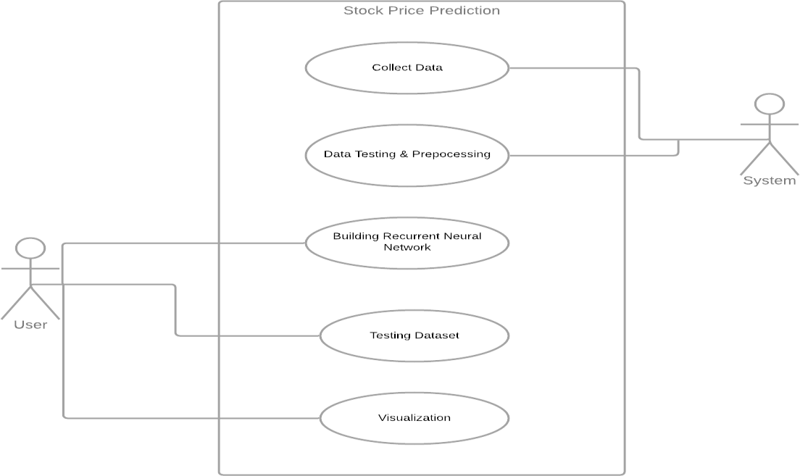

Use case description:

Use case ID: 1
Use case name: Collect data
Description: Start reading the frames and convert the captured frames to HSV color space.

Use case ID: 2
Use case name: Prepare the canvas frame & Training
Description: Prepare the canvas frame and put the respective ink buttons on it. Adjust the track bar values for finding the mask of the colored marker.

Use case ID: 3
Use case name: Building and processing the mask
Description: Preprocess the mask with morphological operations(Eroding and dilation).

Use case ID: 4
Use case name: Detect the contours
Description: Detect the contours, find the center coordinates of largest contours and keep storing them in the array for successive frames(Arrays for drawing points on canvas).

Use Case ID: 5
Use Case Name: Visualization
Description: Finally draw the points stored in an array on the frames and canvas
Chapter 4
Design

4.1 Software Model Followed:
Waterfall Model
The waterfall model is a sequential design process, often used in software development processes, in which progress is seen as flowing steadily downwards (like a waterfall) through the phases of Conception, Initiation, Analysis, Design, Coding, Testing, Implementation, and Maintenance.
PROBLEM DEFINATION

ANALYSIS

DESIGN

CODING

TESTING

IMPLEMENTATION

MAINTENANCE

Phases of System Development:

- Problem Definition and Description This deals with preparing a concise statement of the problem to be solved. Here is a detail description of the present system and an overview of the system is stated.

- Analysis Analysis is the process diagnosing situation, done with a defiant aim, with the boundaries of the system kept in mind to produce a report based on the findings. Analysis is a fact finding technique where system requirement specifications, feasibility analysis and cost benefit analysis are carried out.

- Design Design is concerned with identifying the software components, specifying relationship among components, specifying software structure, maintaining a record of design decisions and providing a blueprint for the implementation phase.

- Coding Coding performs the translations of the design representations into an artificial language resulting in instructions that can be executed by the computer, it thus involves developing computer programs that meet the system specifications of the design stage.

- Testing Testing process focuses on the logical internals of the software, ensuring that all statements have been tested on the functional externals that is conducting tests using various tests data to uncover errors and ensure that defined input will produce actual result that agree with required results.

- Implementation Implementation is a process that includes all those activities that take place to convert an old system to a new system. The new system may be totally new system replacing the existing or it may be the major modification to the existing system.

- Maintenance Software will undergo changes after it has been delivered to the customer. Change will occur because of many reasons such as: errors have been encountered, the user requires functional or performance enhancements, following the acceptance by customer. The software is released for production works and enters the maintenance reapplies each of the capabilities, adaptations of the software to the new processing environments to the correction of the software bugs.

Advantages
The advantage of waterfall development is that it allows for departmentalization and managerial control. A schedule can be set with deadlines for each stage of development and a product can proceed through the development process like a car in a carwash, and theoretically, be delivered on time. Development moves from concept, through design, implementation, testing, installation, troubleshooting, and ends up at operation and maintenance. Each phase of development proceeds in strict order, without any overlapping or iterative steps.

Disadvantages
The disadvantage of waterfall development is that it does not allow for much reflection or revision. Once an application is in the testing stage, it is very difficult to go back and change something that was not well-thought out in the concept stage. Alternatives to the waterfall model include joint application development (JAD), rapid application development (RAD), synch and stabilize, build and fix, and the spiral model.

  - Colour Tracking of Object at fingertip:
Firts of all, The incoming image from the webcam is to be converted to the HSV colour space for detecting the colored object at the tip of finger. The below code snippet converts the incoming image to the HSV space, which is very suitable and perfect color space for Color tracking.
# Loading the default webcam of PC.
cap = cv2.VideoCapture(0)

# In loop
ret, frame = cap.read()
#Flipping the frame to see same side of yours
frame = cv2.flip(frame, 1)
hsv = cv2.cvtColor(frame, cv2.COLOR_BGR2HSV)

We will make the Trackbars to arrange the HSV values to the required range of color of the colored object that we have placed at our finger. The various HUE and other ranges of different colors can be seen here.
# Creating the trackbars needed for adjusting the marker colour
cv2.namedWindow("Color detectors")
cv2.createTrackbar("Upper Hue", "Color detectors", 153, 180,setValues)
cv2.createTrackbar("Upper Saturation", "Color detectors", 255, 255,setValues)
cv2.createTrackbar("Upper Value", "Color detectors", 255, 255,setValues)
cv2.createTrackbar("Lower Hue", "Color detectors", 64, 180,setValues)
cv2.createTrackbar("Lower Saturation", "Color detectors", 72, 255,setValues)
cv2.createTrackbar("Lower Value", "Color detectors", 49, 255,setValues)
When the trackbars are setup, we will get the realtime value from the trackbars and create range. This range is a numpy structure which is used to be passed in the function cv2.inrange( ). This function returns the Mask on the colored object. This Mask is a black and white image with white pixels at the position of the desired color.
#Getting the realtime values from the trackbars for color detection
u_hue = cv2.getTrackbarPos("Upper Hue", "Color detectors")
u_saturation = cv2.getTrackbarPos("Upper Saturation", "Color detectors")
u_value = cv2.getTrackbarPos("Upper Value", "Color detectors")
l_hue = cv2.getTrackbarPos("Lower Hue", "Color detectors")
l_saturation = cv2.getTrackbarPos("Lower Saturation", "Color detectors")
l_value = cv2.getTrackbarPos("Lower Value", "Color detectors")

#Upper and lower are range within which color can be found
Upper_hsv = np.array([u_hue,u_saturation,u_value])
Lower_hsv = np.array([l_hue,l_saturation,l_value])

# Position of the pointer by making its mask
Mask = cv2.inRange(hsv, Lower_hsv, Upper_hsv)

  - Contour Detection of the Mask of Color Object:
Now, After detecting the Mask in Air Canvas, Now is the time to locate its center position for drawing the Line. Here, In the below Snippet of Code, We are performing some morphological operations on the Mask, to make it free of impurities and to detect contour easily.
# Operations to remove impurities and false predictions
Mask = cv2.erode(Mask, kernel, iterations=1)
Mask = cv2.morphologyEx(Mask, cv2.MORPH_OPEN, kernel)
Mask = cv2.dilate(Mask, kernel, iterations=1)

# Find contours for the pointer
cnts,_ = cv2.findContours(Mask.copy(), cv2.RETR_EXTERNAL,
cv2.CHAIN_APPROX_SIMPLE)
center = None

# If the contours are formed, find center of contour (Position)
if len(cnts) > 0:
# sorting the contours to find biggest
cnt = sorted(cnts, key = cv2.contourArea, reverse = True)[0]
# Get the radius of the enclosing circle around the found contour
((x, y), radius) = cv2.minEnclosingCircle(cnt)
# Draw the circle around the contour
cv2.circle(frame, (int(x), int(y)), int(radius), (0, 255, 255), 2)
# Calculating the center of the detected contour
M = cv2.moments(cnt)
center = (int(M['m10'] / M['m00']), int(M['m01'] / M['m00']))

  - Drawing the Line using the position of Contour:
Now Comes the real logic behind this Computer Vision project, We will form a python deque (A data Structure). The deque will store the position of the contour on each successive frame and we will use these stored points to make a line using OpenCV drawing functions.Firstly Make Four deques, for four distinct colors of the project
bpoints = [deque(maxlen=1024)]
gpoints = [deque(maxlen=1024)]
rpoints = [deque(maxlen=1024)]
ypoints = [deque(maxlen=1024)]

# These indexes will be used to mark the points in particular arrays of specific color
blue_index = 0
green_index = 0
red_index = 0
yellow_index = 0

#Color array for changing the drawing colors
colors = [(255, 0, 0), (0, 255, 0), (0, 0, 255), (0, 255, 255)]
colorIndex = 0

Now, we will use the position of the contour to make decision, if we want to click on a button or we want to draw on the sheet. We have arranged some of the buttons on the top of Canvas, if the pointer comes into their area, we will trigger their method. We have four buttons on the canvas, drawn using OpenCV.
- Clear : Which clears the screen by emptying the deques.
- Red : Changes the marker to red color using color array.
- Green : Changes the marker to Green color using color array.
- Yellow : Changes the marker to Yellow color using color array.
- Blue : Changes the marker to Blue color using color array.
Also, to avoid drawing when contour is not present, We will Put a else condition which will capture that instant.
# Now checking if the user wants to click on any button above the screen
if center[1] <= 65:
if 40 <= center[0] <= 140: # Clear Button
bpoints = [deque(maxlen=512)]
gpoints = [deque(maxlen=512)]
rpoints = [deque(maxlen=512)]
ypoints = [deque(maxlen=512)]

blue_index = 0
green_index = 0
red_index = 0
yellow_index = 0

paintWindow[67:,:,:] = 255
elif 160 <= center[0] <= 255:
colorIndex = 0 # Blue
elif 275 <= center[0] <= 370:
colorIndex = 1 # Green
elif 390 <= center[0] <= 485:
colorIndex = 2 # Red
elif 505 <= center[0] <= 600:
colorIndex = 3 # Yellow
else :
if colorIndex == 0:
bpoints[blue_index].appendleft(center)
elif colorIndex == 1:
gpoints[green_index].appendleft(center)
elif colorIndex == 2:
rpoints[red_index].appendleft(center)
elif colorIndex == 3:
ypoints[yellow_index].appendleft(center)

# Append the next deques when nothing is detected to avoid messing up
else:
bpoints.append(deque(maxlen=512))
blue_index += 1
gpoints.append(deque(maxlen=512))
green_index += 1
rpoints.append(deque(maxlen=512))
red_index += 1
ypoints.append(deque(maxlen=512))
yellow_index += 1

  - Drawing the Line using the position of Contour:
Now we will draw all the points on the positions stored in the deques, with respective colour
# Draw lines of all the colors on the canvas and frame
points = [bpoints, gpoints, rpoints, ypoints]
for i in range(len(points)):
for j in range(len(points[i])):
for k in range(1, len(points[i][j])):
if points[i][j][k - 1] is None or points[i][j][k] is None:
continue
cv2.line(frame, points[i][j][k - 1], points[i][j][k], colors[i], 2)
cv2.line(paintWindow, points[i][j][k - 1], points[i][j][k], colors[i], 2)

# Show all the windows
cv2.imshow("Paint", paintWindow)

  - Data Flow Diagram
Level 0 -DFD
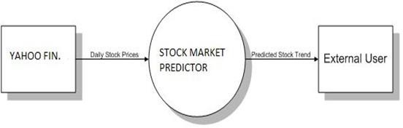

Level 1- DFD

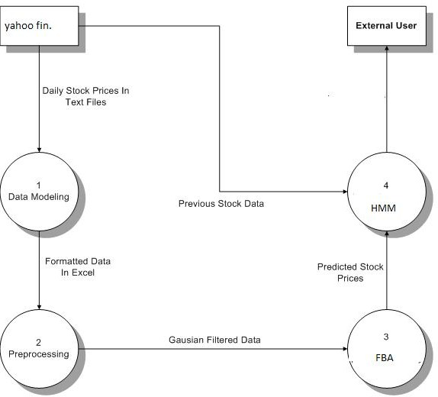

Chapter 5
Coding

import numpy as np
import cv2
from collections import deque

#default called trackbar function
def setValues(x):
print("")

# Creating the trackbars needed for adjusting the marker colour
cv2.namedWindow("Color detectors")
cv2.createTrackbar("Upper Hue", "Color detectors", 153, 180,setValues)
cv2.createTrackbar("Upper Saturation", "Color detectors", 255, 255,setValues)
cv2.createTrackbar("Upper Value", "Color detectors", 255, 255,setValues)
cv2.createTrackbar("Lower Hue", "Color detectors", 64, 180,setValues)
cv2.createTrackbar("Lower Saturation", "Color detectors", 72, 255,setValues)
cv2.createTrackbar("Lower Value", "Color detectors", 49, 255,setValues)

# Giving different arrays to handle colour points of different colour
bpoints = [deque(maxlen=1024)]
gpoints = [deque(maxlen=1024)]
rpoints = [deque(maxlen=1024)]
ypoints = [deque(maxlen=1024)]

# These indexes will be used to mark the points in particular arrays of specific colour
blue_index = 0
green_index = 0
red_index = 0
yellow_index = 0

#The kernel to be used for dilation purpose
kernel = np.ones((5,5),np.uint8)

colors = [(255, 0, 0), (0, 255, 0), (0, 0, 255), (0, 255, 255)]
colorIndex = 0

# Here is code for Canvas setup
paintWindow = np.zeros((471,636,3)) + 255
paintWindow = cv2.rectangle(paintWindow, (40,1), (140,65), (0,0,0), 2)
paintWindow = cv2.rectangle(paintWindow, (160,1), (255,65), colors[0], -1)
paintWindow = cv2.rectangle(paintWindow, (275,1), (370,65), colors[1], -1)
paintWindow = cv2.rectangle(paintWindow, (390,1), (485,65), colors[2], -1)
paintWindow = cv2.rectangle(paintWindow, (505,1), (600,65), colors[3], -1)

cv2.putText(paintWindow, "CLEAR", (49, 33), cv2.FONT_HERSHEY_SIMPLEX, 0.5, (0, 0, 0), 2, cv2.LINE_AA)
cv2.putText(paintWindow, "BLUE", (185, 33), cv2.FONT_HERSHEY_SIMPLEX, 0.5, (255, 255, 255), 2, cv2.LINE_AA)
cv2.putText(paintWindow, "GREEN", (298, 33), cv2.FONT_HERSHEY_SIMPLEX, 0.5, (255, 255, 255), 2, cv2.LINE_AA)
cv2.putText(paintWindow, "RED", (420, 33), cv2.FONT_HERSHEY_SIMPLEX, 0.5, (255, 255, 255), 2, cv2.LINE_AA)
cv2.putText(paintWindow, "YELLOW", (520, 33), cv2.FONT_HERSHEY_SIMPLEX, 0.5, (150,150,150), 2, cv2.LINE_AA)
cv2.namedWindow('Paint', cv2.WINDOW_AUTOSIZE)

# Loading the default webcam of PC.
cap = cv2.VideoCapture(0)

# Keep looping
while True:
# Reading the frame from the camera
ret, frame = cap.read()
#Flipping the frame to see same side of yours
frame = cv2.flip(frame, 1)
hsv = cv2.cvtColor(frame, cv2.COLOR_BGR2HSV)

u_hue = cv2.getTrackbarPos("Upper Hue", "Color detectors")
u_saturation = cv2.getTrackbarPos("Upper Saturation", "Color detectors")
u_value = cv2.getTrackbarPos("Upper Value", "Color detectors")
l_hue = cv2.getTrackbarPos("Lower Hue", "Color detectors")
l_saturation = cv2.getTrackbarPos("Lower Saturation", "Color detectors")
l_value = cv2.getTrackbarPos("Lower Value", "Color detectors")
Upper_hsv = np.array([u_hue,u_saturation,u_value])
Lower_hsv = np.array([l_hue,l_saturation,l_value])

# Adding the colour buttons to the live frame for colour access
frame = cv2.rectangle(frame, (40,1), (140,65), (122,122,122), -1)
frame = cv2.rectangle(frame, (160,1), (255,65), colors[0], -1)
frame = cv2.rectangle(frame, (275,1), (370,65), colors[1], -1)
frame = cv2.rectangle(frame, (390,1), (485,65), colors[2], -1)
frame = cv2.rectangle(frame, (505,1), (600,65), colors[3], -1)
cv2.putText(frame, "CLEAR ALL", (49, 33), cv2.FONT_HERSHEY_SIMPLEX, 0.5, (255, 255, 255), 2, cv2.LINE_AA)
cv2.putText(frame, "BLUE", (185, 33), cv2.FONT_HERSHEY_SIMPLEX, 0.5, (255, 255, 255), 2, cv2.LINE_AA)
cv2.putText(frame, "GREEN", (298, 33), cv2.FONT_HERSHEY_SIMPLEX, 0.5, (255, 255, 255), 2, cv2.LINE_AA)
cv2.putText(frame, "RED", (420, 33), cv2.FONT_HERSHEY_SIMPLEX, 0.5, (255, 255, 255), 2, cv2.LINE_AA)
cv2.putText(frame, "YELLOW", (520, 33), cv2.FONT_HERSHEY_SIMPLEX, 0.5, (150,150,150), 2, cv2.LINE_AA)

# Identifying the pointer by making its mask
Mask = cv2.inRange(hsv, Lower_hsv, Upper_hsv)
Mask = cv2.erode(Mask, kernel, iterations=1)
Mask = cv2.morphologyEx(Mask, cv2.MORPH_OPEN, kernel)
Mask = cv2.dilate(Mask, kernel, iterations=1)

# Find contours for the pointer after idetifying it
cnts,_ = cv2.findContours(Mask.copy(), cv2.RETR_EXTERNAL,
cv2.CHAIN_APPROX_SIMPLE)
center = None

# Ifthe contours are formed
if len(cnts) > 0:
# sorting the contours to find biggest
cnt = sorted(cnts, key = cv2.contourArea, reverse = True)[0]
# Get the radius of the enclosing circle around the found contour
((x, y), radius) = cv2.minEnclosingCircle(cnt)
# Draw the circle around the contour
cv2.circle(frame, (int(x), int(y)), int(radius), (0, 255, 255), 2)
# Calculating the center of the detected contour
M = cv2.moments(cnt)
center = (int(M['m10'] / M['m00']), int(M['m01'] / M['m00']))

# Now checking if the user wants to click on any button above the screen
if center[1] <= 65:
if 40 <= center[0] <= 140: # Clear Button
bpoints = [deque(maxlen=512)]
gpoints = [deque(maxlen=512)]
rpoints = [deque(maxlen=512)]
ypoints = [deque(maxlen=512)]

blue_index = 0
green_index = 0
red_index = 0
yellow_index = 0

paintWindow[67:,:,:] = 255
elif 160 <= center[0] <= 255:
colorIndex = 0 # Blue
elif 275 <= center[0] <= 370:
colorIndex = 1 # Green
elif 390 <= center[0] <= 485:
colorIndex = 2 # Red
elif 505 <= center[0] <= 600:
colorIndex = 3 # Yellow
else :
if colorIndex == 0:
bpoints[blue_index].appendleft(center)
elif colorIndex == 1:
gpoints[green_index].appendleft(center)
elif colorIndex == 2:
rpoints[red_index].appendleft(center)
elif colorIndex == 3:
ypoints[yellow_index].appendleft(center)
# Append the next deques when nothing is detected to avois messing up
else:
bpoints.append(deque(maxlen=512))
blue_index += 1
gpoints.append(deque(maxlen=512))
green_index += 1
rpoints.append(deque(maxlen=512))
red_index += 1
ypoints.append(deque(maxlen=512))
yellow_index += 1

# Draw lines of all the colors on the canvas and frame
points = [bpoints, gpoints, rpoints, ypoints]
for i in range(len(points)):
for j in range(len(points[i])):
for k in range(1, len(points[i][j])):
if points[i][j][k - 1] is None or points[i][j][k] is None:
continue
cv2.line(frame, points[i][j][k - 1], points[i][j][k], colors[i], 2)
cv2.line(paintWindow, points[i][j][k - 1], points[i][j][k], colors[i], 2)

# Show all the windows
cv2.imshow("Tracking", frame)
cv2.imshow("Paint", paintWindow)
cv2.imshow("mask",Mask)

# If the 'q' key is pressed then stop the application
if cv2.waitKey(1) & 0xFF == ord("q"):
break

# Release the camera and all resources
cap.release()
cv2.destroyAllWindows()

Chapter 6
Implementation And Screenshots

6.1 Implementation

Implementation is the stage in the project where the theoretical design is turned into the working system and is giving confidence to the new system for the users i.e. will work efficiently and effectively. It involves careful planning, investigation of the current system and its constraints on implementation, design of method to achieve the change over, an evaluation, of change over methods. A part from planning major task of preparing the implementation is education of users. The more complex system is implemented, the more involved will be the system analysis and design effort required just for implementation. An implementation coordinating committee based on policies of individual organization has been appointed. The implementation process begins with preparing a plan for the implementation for the system. According to this plan, the activities are to be carried out, discussions may regarding the equipment has to be acquired to implement the new system.

Implementation is the final and important phase. The most critical stage is in achieving a successful new system and in giving the users confidence that the new system will work and be effective. The system can be implemented only after thorough testing is done and if it found to working according to the specification. This method also offers the greatest security since the old system can take over if the errors are found or inability to handle certain types of transaction while using the new system.

The major elements of implementation plan are test plan, training plan, equipment installation plan, and a conversion plan.

When someone Run this window application, this page will be open first. Then if user have account then they will login otherwise they will first have to register.

6.2 Screenshots

After Run this application, this page will be open first. Then the user has to enter a specific point i.e. position of the finger from where he will start writting

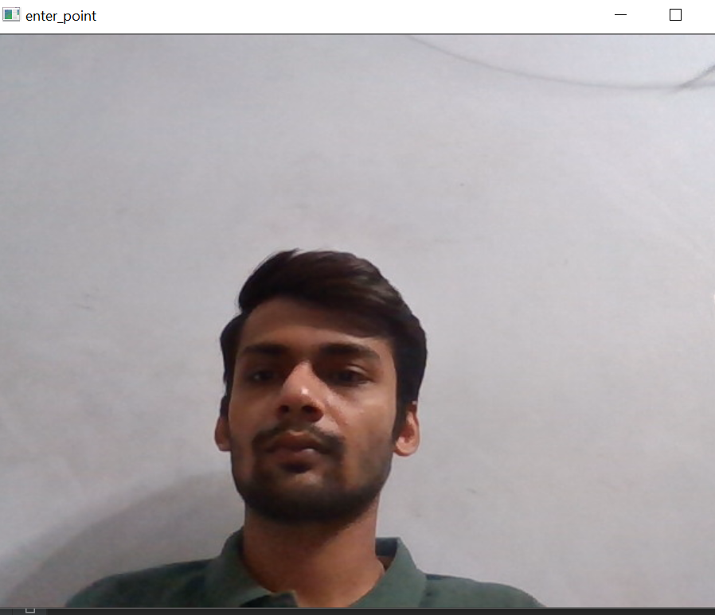

After the user has entered the point a mark will appear at that point which user has selected with some specific instructions.
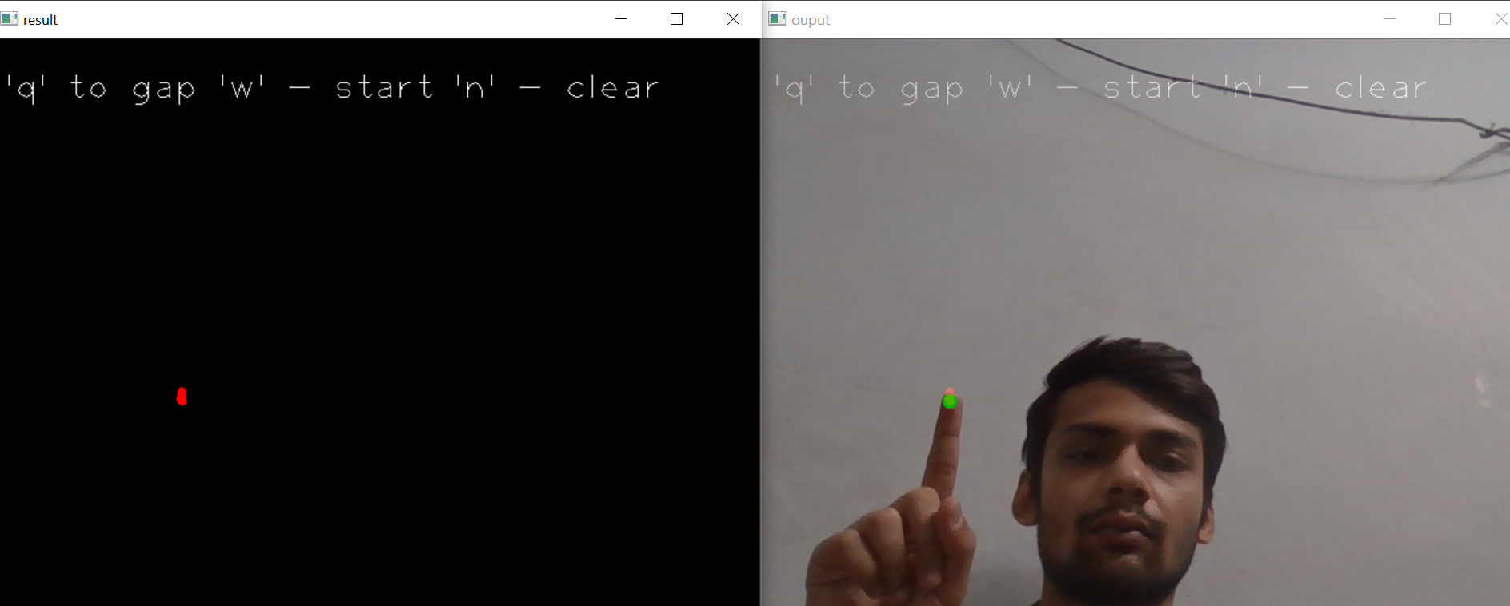

Once the location has been marked user can write draw whatever he wants to.

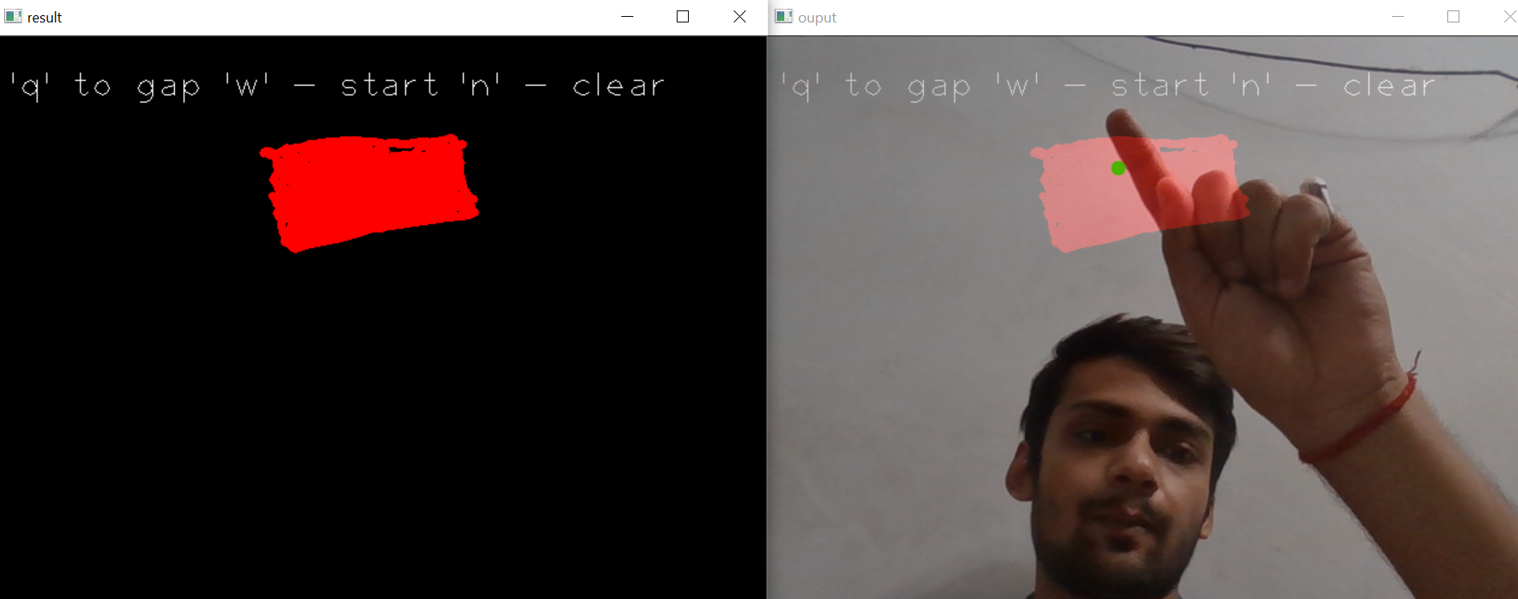

Chapter 7
Advantages And Maintenance

7.1 Advantages

- Better Efficiency in Delivering Services:
Project management provides a “roadmap” that is easily followed and leads to project completion. Once you know where to avoid the bumps and pots holes it stands to reason that you’re going to be working smarter and not harder and longer.

- Improved / Increased / Enhanced Customer Satisfaction:
Whenever you get a project done on time and under budget, the client walks away happy. And a happy client is one you’ll see again. Smart project management provides the tools that enable this client/manager relationship to continue.

- Enhanced Effectiveness in Delivering Services:
The same strategies that allowed you to successfully complete one project will serve you many times over.

- Improved Growth and Development Within your Team:
Positive results not only command respect but more often than not inspire your team to continue to look for ways to perform more efficiently.

- Greater Standing and Competitive Edge:
This is not only a good benefit of project management within the workplace but outside of it as well; word travels fast and there is nothing like superior performance to secure your place in the marketplace.

- Opportunities to Expand your Services:
A by-product of greater standing. Great performance leads to more opportunities to succeed.

- Better Flexibility:
Perhaps one of the greatest benefits of project management is that it allows for flexibility. Sure project management allows you to map out the strategy you want to take see your project completed. But the beauty of such organization is that if you discover a smarter direction to take, you can take it. For many small-to-midsize companies, this alone is worth the price of admission.

- Increased Risk Assessment:
When all the players are lined up and your strategy is in place potential risks will jump out and slap you in the face. And that’s the way it should be. Project management provides a red flag at the right time: before you start working on project completion.

- Increase in Quality:
Goes hand-in-hand with enhanced effectiveness.

- Increase in Quantity:
I saved the best for last> And increase in quality is often the result of better efficiency, a simple reminder regarding the benefits of project management.

7.2 Maintenance

Once the window application is launched, it enters the maintenance phase. All systems need maintenance. Maintenance is required because there are often some residual errors remaining in the system that must be removed as they are discovered. Maintenance involves understanding the effects of the change, making the changes to both the code and the documents, testing the new parts and retesting the old parts that were not changed. Maintenance is mainly of two types:
1. Corrective Maintenance
2. Adaptive Maintenance

Corrective Maintenance:
Almost all software that is developed has residual errors or bugs in them. Many of these surfaces only after the system have been in operation, sometimes for a long time. These errors once discovered need to be removed, leading to the software to be changed. This is called Corrective Maintenance.

Adaptive Maintenance:
Even without bugs, software frequently undergoes change. The software often must be upgraded and enhanced to include more features and provide more services. This requires modification of the software. This type of maintenance is known as the Adaptive Maintenance.

Chapter 8
Reference

[1] Viraktamath SV, Mukund Katti, Aditya Khatawkar, Pavan Kulkarni, “Face Detection and Tracking using OpenCV,” The SIJ Transaction on Computer Networks & Communication Engineering (CNCE), 2013, 1(3).

[2] Pant A, Arora A, Kumar S, Arora RP. “Sophisticated Image secret writing exploitation OpenCV,” International Journal of Advances Research in Computer Science and Software Engineering, 2012, 2(1).

[3] Kevin Hughes – an added golem learns to exam-ine (http://kevinhughes.ca)

[4] Belongie S, Malik J, Puzicha J. “Shape Matching and beholding exploitation form contexts,” IEEE Transactions on Pattern Analysis and Machine Intelligence, 2002; 24(4):509-522,

[5] Abdesselam Bouzerdoum, Azeddine Beghdadi and Philippe L. Bouttefroy , “On the analysis of background subtraction techniques using Gaussian mixture models,” 2010 IEEE International Conference on Acoustics, Speech, and Signal Processing (pp. 4042-4045). USA: IEEE.

[6] Bhoomi Gupta, “http://jardcs.org/backissues/abstract.php?archiveid=63 46”, A Novel Approach for Multi Exposure Image fusion using Deep Learning, Journal of Advanced Research in Dynamics & Control Systems, Vol. 10, 14- Special Issue, 2018, ISSN 1943-023X, pg. 1526-1531.

[7] Nidhi, “Image Processing and Object Detection”, Dept. of Computer Applications, NIT, Kurukshetra, Haryana, 1(9): 396-399, 2015

